**This form should be completed within first 2 weeks after admission.**

**Here are the most important things to me that will help make every day a good day**

*Tom Kitwood identified five psychological needs that people have, in order to feel ‘unconditional positive regard’, or simply put; love.*

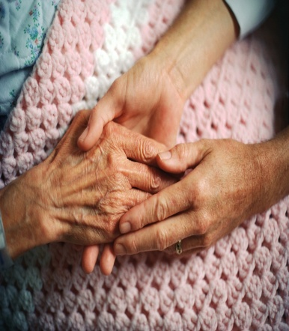

**Comfort is the need for**

Emotional and physical comfort

Tenderness

Closeness

Soothing and relaxing through physical touch or words or gestures

Security

**Attachment is the need to**

Feel bonded to and have a relationship with other people, but also animals and objects

Feel nurtured

Be able to trust

Have a sense of security with others

**Occupation is the need to**

Be involved in the process of life,

Doing things that have meaning for us

Feel we have control over the word around us

Feel useful and engaged

**Inclusion is the need to**

Be brought in to the social world, either physically or verbally

Being given opportunities for engagement and

Feel part of a group

Feel valued, welcomed and accepted by others

**Identity is the need for**

Knowing who you are and that others know who you are

A sense of continuity with the past

A life story that is held and maintained by yourself or someone else in the day-to-day experience of living